OS LAB 09

NAME: SHAHERYAR SIDDQUI ID: FA17-BECE-0023

TASK 1:

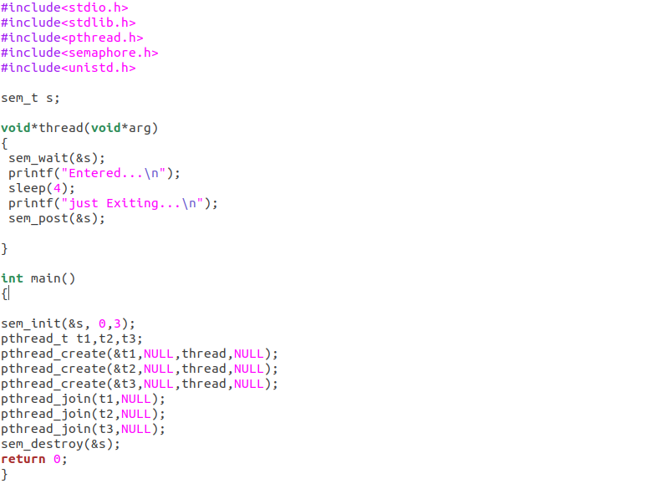
OUTPUT:

If s=1:

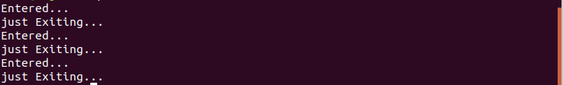

If s=5:

